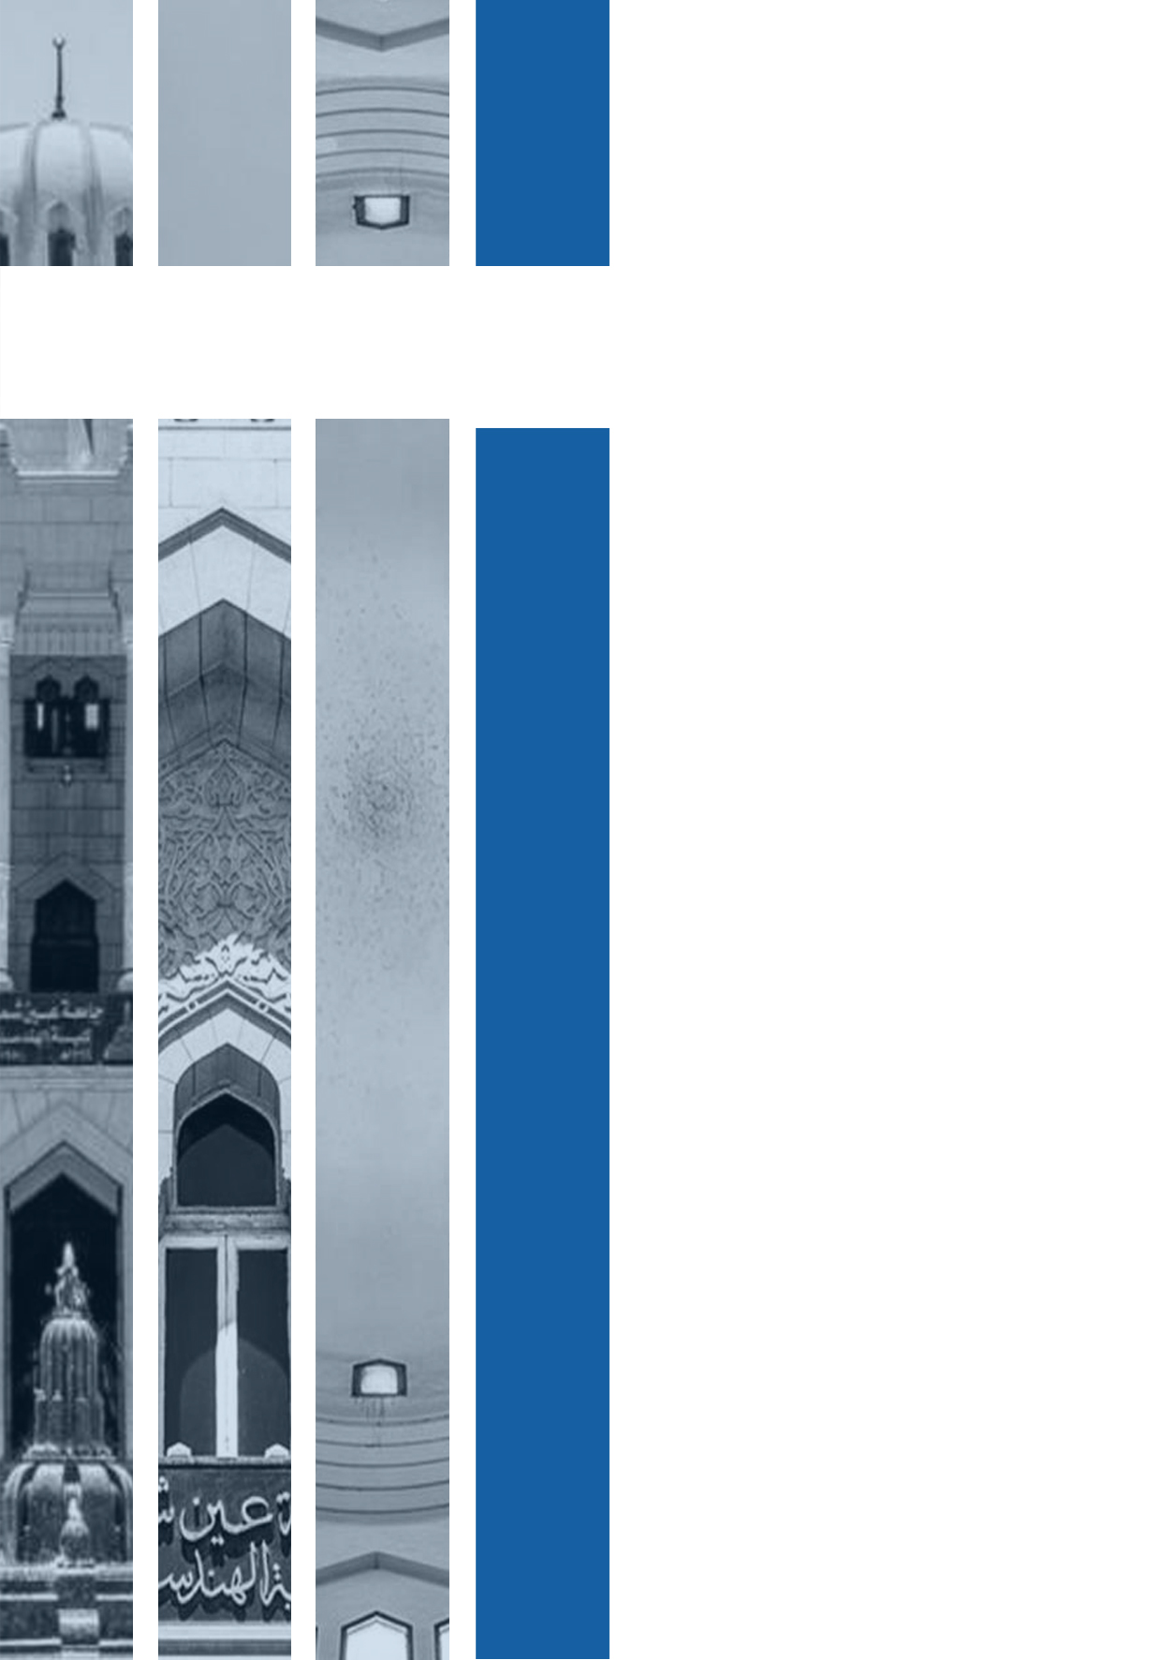

**Student name:** **Mohamed Khaled Sayed Ibrahim Mohran**

**Section: 4**

**Student ID: 1601166**

Assignment 1

# 